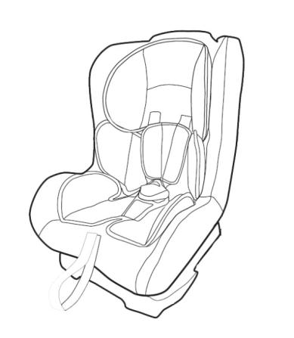

**Baby Car Seat**

**0+，I Group**

**Suitable for 0-18 kg**

**Fitting instructions**

Notice

First thank you for using our baby car seat，it is approved to Regulation No.44.04. This car seat is made according to Regulation No.44.04. Only suitable if the approved vehicles are fitted with 3-point safety-belts，suitable for 0-18kgs. These instructions are important. Please read carefully and retain for future reference. Otherwise the manufacturer is not responsible for the fitting which not follow these instructions.

WARNING

1. Do not use this child seat in Passenger seats equipped with airbags.
2. This car seat is suitable for 0-18kg (group 0+，1)
3. This child seat can only be installed forward facing using a three-point lap and diagonal seat belt.
4. Do not use this child seat in the home. It has not been designed for home use and should only be used in your car.
5. This safest seating position for the child car seat is on the rear seat of a vehicle.
6. Never use the child seat without fastening it into the car.
7. It’s dangerous to make any alteration or additions to the device without the approval of the competent authority, and a danger of not following closely the installation instructions provided by the child restraint manufacturer.
8. Do not leave your child unattended in the seat at any time.
9. The seat should be kept away from sunlight if the seat is not provided with a textile, otherwise it may be too hot for the child’s skin.
10. In the event of an emergency it is important that the child can be released quickly, this means that the buckle is not fully tamper proof and so your child must be taught never to play with the buckle.
11. Any luggage or other objects liable to cause injuries in the event of a collision shall be properly secured.
12. Periodically inspect the harness for wear, playing particular attention to attachment points, stitching and adjusting devices.
13. The rigid items and plastic parts of a child restraint must be so located and installed that they are not liable, during everyday use of the vehicle to become trapped by a moveable seat or in a door of the vehicle.
14. Always make sure that any straps holding the seat restraint to the vehicle shall be tight, any straps restraining the child should be adjusted to the child’s body, and check that the straps shall not be twisted.
15. The seat device should be changed when it has been subject to violent stresses in a accident.
16. Do not use any load bearing contact points other than those described in the instructions and marked in the child restraint.
17. Store this child seat in a safe place when it is not being used. Avoid placing heavy objects on top of it. Do not allow your child seat to come into contact with corrosive substances e.g. battery acid.
18. The child restraint must not be used without the cover. The seat cover should not be replaced with any other than the one recommended by the manufacturer, because the cover constitutes an integral part of the restraint performance.

PARTS AND FITTINGS



Headrest Pad

Backrest

Harness straps

Backrest pad

Chest pad

Adjuster

Buckle pad

Buckle

Harness adjuster strap

Comfort pad



Base

Positioning handle

THE TYPE OF APPROVED SEAT BELT YOU MUST HAVE

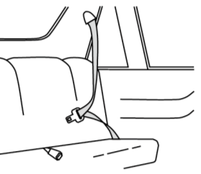

**WARNING: THE CAR SEAT SHOULD NOT BE FITTED**

**IN A PASSENGER SEAT OF A CAR THAT**

Diagona l belt

**HAS AN AIR BAG FITTED.(SRS)**

Your child seat can only be installed forward facing

Lap belt

using a three-point lap and diagonal seat belt in the

front or rear passenger seats of the car.

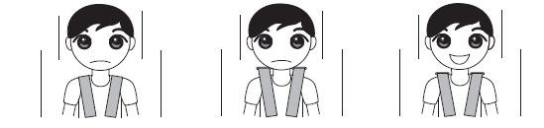

CORRECT SHOULDER STRAP HEIGHT

No-Too low No-Too high YES-Correct

Always check that the shoulder straps are at the correct height for your child. The child’s

shoulders should always be below the slot for the harness.

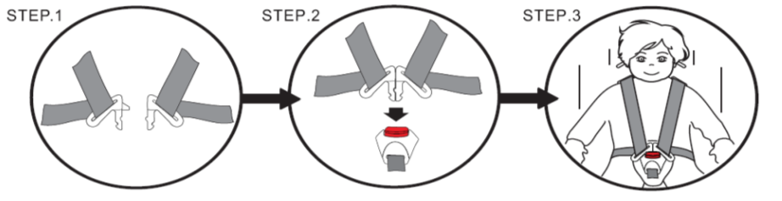

FASTENING THE SAFETY SEAT BUCKLE

1. Slot the two metal sections of the buckle connectors together.

2. Slot the two buckle connectors into the slot in the top of the buckle until they ‘click’

into place.

3. Always check the harness is correctly locked by pulling the shoulder straps upwards.

To release the harness, press the red button on the buckle downwards.

TIGHTING THE HARNESS

Pull the shoulder straps upwards to remove the slack from the lap sections of the harness then pull the adjuster strap until the harness is fully tightened.

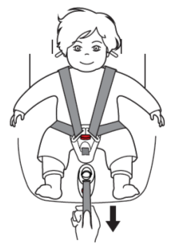

The harness should be adjusted as tightly as possible without causing discomfort to your child.

A loose harness can be dangerous.

Check the harness adjuster and tighten each time the child is placed in the seat.

SLACKENING THE HARNESS

The harness is slackened by pressing the adjuster (under the adjuster cover)on the front of the seat.

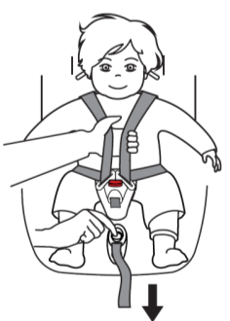

Press down the adjuster as you grip the two shoulder straps with your another hand. Pull the shoulder straps towards you to loosen the harness.

REMOVING ALL STRAPS

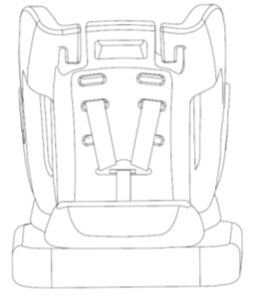

13-18KG

6-13KG

0-6KG

Connector

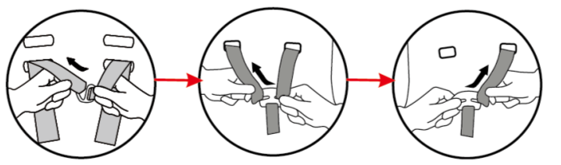

This child seat has three recline positions, you can choose a suitable position to make your

child more comfortable.

1. Press the harness adjuster lever and release the harness adjuster strap.
2. Pull out the connecting shaft which connects the base and backrest together.
3. Make sure the diagonal belts get through the proper slots to the harness connector.

COMFORT PAD USING

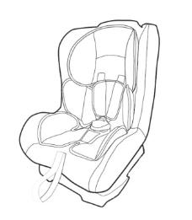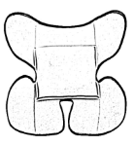

Comfort pad A

1. 0-9 KG ： use the comfort pad A.

2. 9-18 KG ：no need comfort pads.

Backrest recline Positions

This car seat has three different backrest recline positions, it makes the baby feel more comfortable. The first and second positions are for the forward facing, the third position is for the rearward facing.

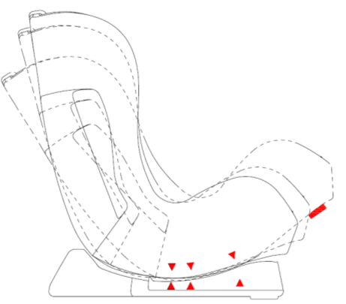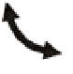

Adjustment：A hand holds the base，the other hand pulls the handle out to a proper position until you hear a ‘click’ sound.

Attention: After make sure the proper recline position, you need to tight the harness seat belt in the car.

Positions handle

Do not adjust the recline positions after tight

Third

First

Second

the harness seat belts.

REARWARD FACING

Rearward facing - Suitable for 0+ group（0-13KG）

Step 1. Make the recline position to the third positon(maximum positon), set the child car

seat onto the car seat with 3-point belt.（Step 1）

Step 2. Put the seat belt ,through the base A position ,then to the other side of position ;

then get through from the position（B1、B2）, fasten the buckle, when heard a ‘click’

Check the webbing of the seat belt has not become twisted or tangled.

Hold the diagonal belt and the lab belt, make sure no spare belt is left. Check the

child seat if it is fixed on the car seat.

Step 2-1

Step 1

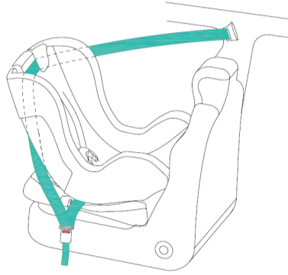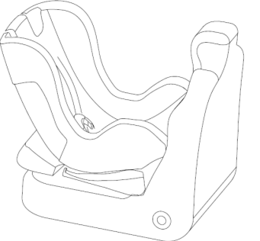

A

Step 2-2

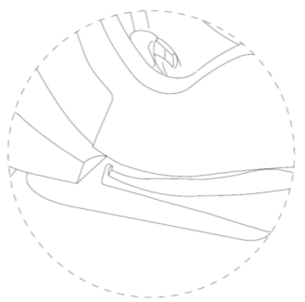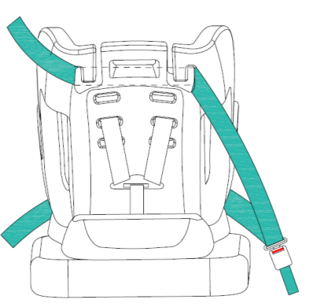

Step 2-3

B1

B2

A

Step 3. Release the buckle on the child car seat.

Step 4. Place your child into the child seat. Check the height of the shoulder straps on the

correct position and fasten the buckle. Check that the harness has not become twisted

and also check that the cover is not impeding the



movement or fit of the harness in any way.

Step 5 . Pull the harness strap , till it fit the baby comfortable.

To disassemble the child seat, repeat the

above prescribed procedures in reverse order.

FORWARD FACING

第一档

Forward facing - Suitable for the group I(9-18kg) ,the first and second position is for the forward facing.

Step 1.Place the child safety seat on the vehicle’s seat ensuring it is firmly press against the car seat backrest

Step 2. Put the car seat belt get through the hook from the top of the backrest

(position B),then make sure the diagonal belt and the lap belt through the side slots

of the backrest, then fasten the belt into the seat belt buckle with a noticeable

‘click’。Check the webbing of the seat belt has not become twisted or tangled.

Also check that the belt buckle is correctly positioned.

Hold the diagonal belt and the lab belt, make sure no spare belt is left. Check the

child seat if it is fixed on the car seat.

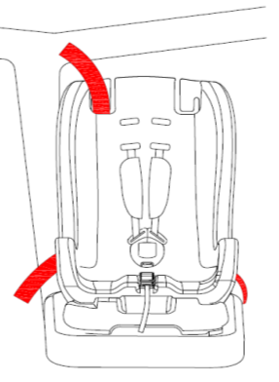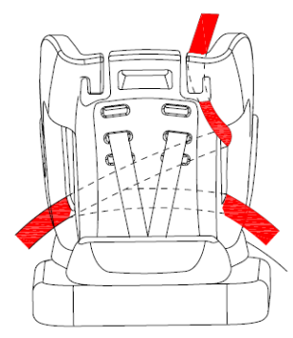

B

hole

Step 3.Release the buckle on the child car seat.

Step 4. Place your child into the child seat. Check the height of the shoulder straps on the



correct position and fasten the buckle. Check that the

harness has not become twisted and also check that the

cover is not impeding the movment or fit of the harness

in any way.

Step 5 . Pull the harness strap , till it fit the baby comfortable.

To disassemble the child seat, repeat the above

prescribed procedures in reverse order.

CARE AND MAINTENANCE

These instructions are important. Please read carefully and retain for future reference。

1. Cover remover: First remove the buckle of the child seat, then slide the backrest cover off. The covers can now be cleaned.

Important: The cover is a safety feature. Never use the child seat without it. Don’t put your child’s safety at risk by using other makes of replacement cover, could stop the child seat form protecing you child as well as it should.

1. Washing instruction:

The cover is removable and washable at 30 degrees, line dry only.

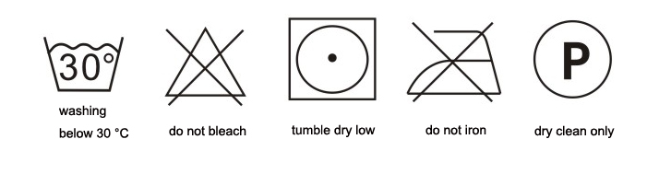

Except trichloroethylene

After sales Service

From the date of purchase within 12 months, if the product fails preventing normal use, we will provide warranty.

Warranty following exceptions are free:

1. The user is not used in accordance with the instruction manual;
2. Users make alterations or demolition;
3. After serious accident safety seat;
4. Due to unexpected disasters cause damage(such as fire, floods, earthquakes, etc.).